PENETRATING TEST ON METASPLOITABLE2
An unauthorized Vulnerability Assessment and Penetrating Testing Report
Prepared By: Ateh Precious
Track : computer Networking
Name: [vulnerability discovered]
Affected service
Service: [e.g., FTP]
Port: [e.g., 21/tcp]
Version: [version discovered by Nmap]
Evidence
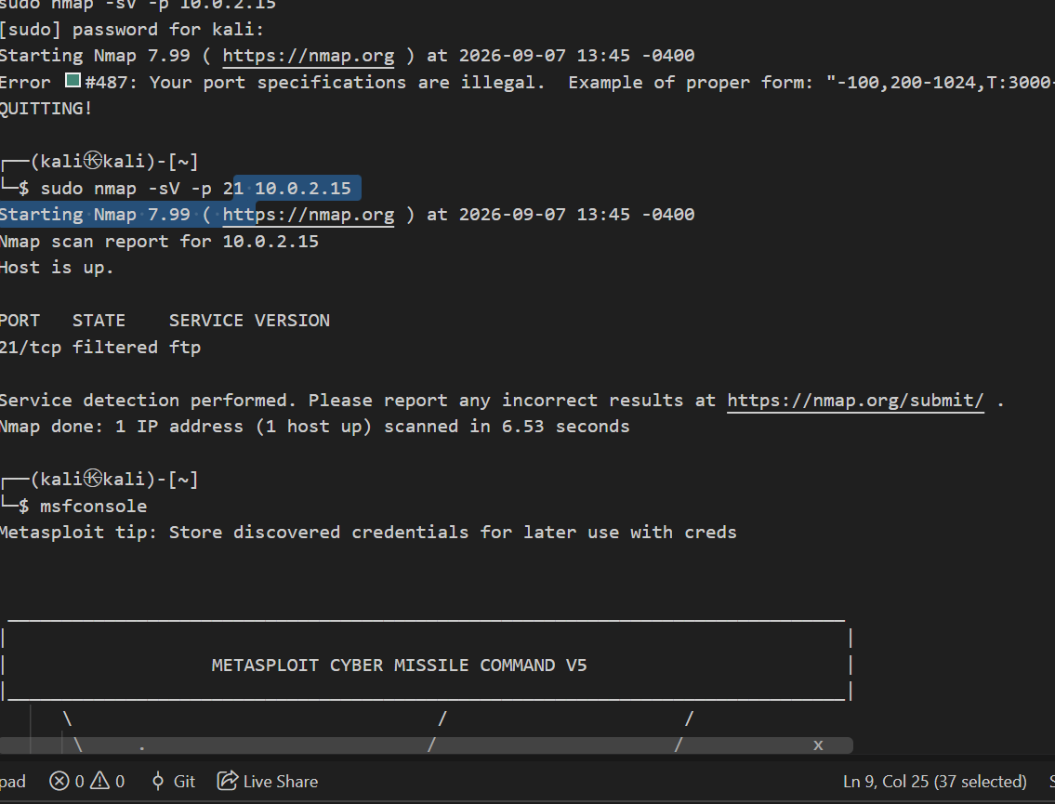
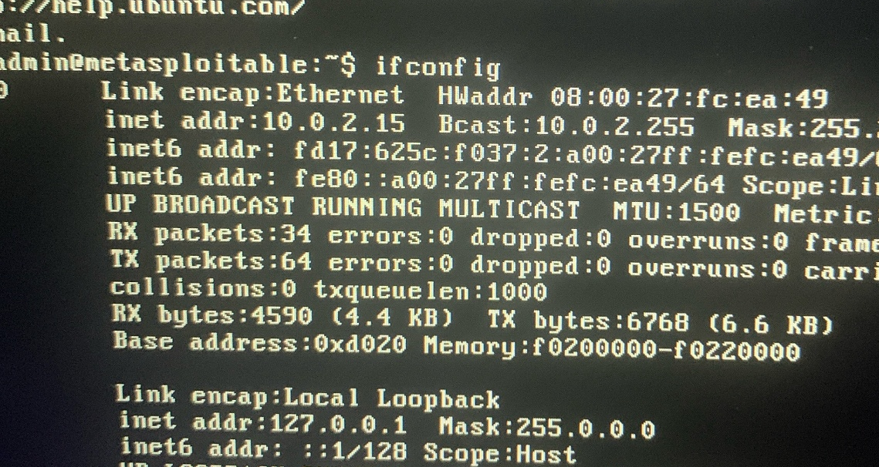

Impact
Explain what an attacker could potentially gain from exploiting the vulnerability, such as unauthorized access or control of the vulnerable system.
Remediation
Recommend things such as:
* Upgrade or replace vulnerable software.
* Disable unnecessary services.
* Restrict exposed ports with a firewall.
* Use strong authentication.
* Keep systems and services patched.
* Monitor suspicious network activity.

